Round 4 and 5

3 feet

6 feet

2.5 feet

0.5 feet

0.33 feet

Round 6

10.6 cubic feet

0.5 cubic feet of play sand

Round 7

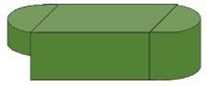

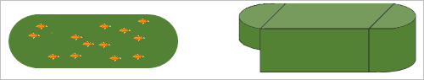

Round 8

radius = 1.5 feet

radius = 1.5 feet

5 feet

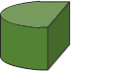

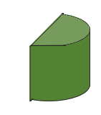

1 feet

2 feet

DEEP END

SHALLOW END

2 feet

MIDDLE SECTION

3 feet

Round 9

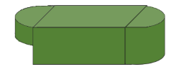

40.6 cubic feet



1” fish = 10 gallons

1 gallon = 0.13 cubic feet